Problem Set 7

SeungWha Lee

Xinyuan Meng

Boyang Pan

1. The 75 estimates of January mean returns are given in the table below.

|  |  |  |  |  |
| --- | --- | --- | --- | --- |
| Size | Past returns | January “extra” mean returns (t-stat) | | |
| **Past 1month return** | **Past 2-12month return** | **Past 13-60month return** |
| Small | **Low** | 8.41 (7.08) | 8.51 (7.25) | 8.33 (7.09) |
| **2** | 5.82 (5.52) | 6.31 (6.05) | 5.58 (5.45) |
| **3** | 4.93 (4.88) | 5.2 (5.32) | 4.15 (4.3) |
| **4** | 4.61 (4.63) | 4.33 (4.4) | 5.45 (5.22) |
| **High** | 4.05 (4.01) | 4.12 (4.24) | 4.52 (4.57) |
| 2 | **Low** | 4.64 (4.46) | 4.82 (4.46) | 4.98 (4.68) |
| **2** | 3.6 (4.15) | 3.79 (4.21) | 3.42 (3.74) |
| **3** | 2.82 (3.4) | 2.87 (3.58) | 2.54 (3.04) |
| **4** | 2.62 (3.07) | 2.23 (2.78) | 1.99 (2.28) |
| **High** | 1.97 (2.24) | 2.01 (2.33) | 1.99 (2.14) |
| 3 | **Low** | 3.57 (3.83) | 3.58 (3.43) | 4.23 (4.17) |
| **2** | 2.75 (3.44) | 2.49 (2.96) | 2.4 (2.83) |
| **3** | 2.2 (2.92) | 2.04 (2.7) | 2.05 (2.63) |
| **4** | 1.81 (2.54) | 1.49 (2.16) | 1.42 (1.91) |
| **High** | 0.78 (0.95) | 1.13 (1.47) | 1.33 (1.69) |
| 4 | **Low** | 2.27 (2.56) | 2.57 (2.46) | 2.64 (2.78) |
| **2** | 1.88 (2.57) | 1.74 (2.17) | 1.48 (1.87) |
| **3** | 1.55 (2.31) | 1.22 (1.74) | 1.21 (1.62) |
| **4** | 0.62 (0.87) | 0.62 (0.91) | 0.89 (1.24) |
| **High** | 0.02 (0.02) | 0.29 (0.4) | 0.35 (0.46) |
| Big | **Low** | 1.16 (1.51) | 1.99 (2.12) | 1.99 (2.84) |
| **2** | 0.72 (1.17) | 1.11 (1.54) | 0.8 (1.22) |
| **3** | 0.19 (0.33) | 0.27 (0.43) | 0.4 (0.62) |
| **4** | 0.15 (0.25) | -0.1 (-0.17) | -0.12 (-0.19) |
| **High** | -0.4 (-0.59) | -0.63 (-0.98) | -0.44 (-0.66) |

Below are the statistics of January dummy:

|  |  |  |  |  |  |
| --- | --- | --- | --- | --- | --- |
|  | mean | Standard error of mean | t-stat | Max | Min |
| $$β_{January}$$ | 2.5375 | 0.2401 | 10.5669 | 8.5095 | -0.6331 |

Yes, there is a strong January seasonal that is different than other months.

Large: small losers

Small: large winners

The 50th portfolio (big size, high past 2-12 month return) has the smallest seasonality and the 26th portfolio (small size, low past 2-12 month return) has the largest seasonality.

Reasons:

1. The 75 estimates of December mean returns are given in the table below.

|  |  |  |  |  |
| --- | --- | --- | --- | --- |
| Size | Past returns | December “extra” mean returns | | |
| **Past 1month return** | **Past 2-12month return** | **Past 13-60month return** |
| Small | **Low** | -0.33 (-0.28) | -1.18 (-1) | -0.28 (-0.23) |
| **2** | 0 (0) | -0.51 (-0.49) | 0.07 (0.07) |
| **3** | -0.29 (-0.29) | -0.52 (-0.53) | 0.25 (0.26) |
| **4** | -0.54 (-0.54) | 0.11 (0.12) | -0.02 (-0.02) |
| **High** | -0.12 (-0.12) | 1.07 (1.1) | 0.65 (0.65) |
| 2 | **Low** | 0.78 (0.75) | -0.19 (-0.17) | 0.84 (0.78) |
| **2** | 0.84 (0.96) | 0.43 (0.48) | 1.06 (1.15) |
| **3** | 0.79 (0.94) | 0.97 (1.2) | 1.1 (1.3) |
| **4** | 1.1 (1.28) | 1.45 (1.8) | 0.8 (0.91) |
| **High** | 1.09 (1.24) | 1.6 (1.83) | 0.69 (0.73) |
| 3 | **Low** | 1.23 (1.31) | 0.58 (0.55) | 1.55 (1.51) |
| **2** | 0.96 (1.19) | 0.74 (0.87) | 1.18 (1.38) |
| **3** | 1.2 (1.59) | 0.91 (1.19) | 1.53 (1.95) |
| **4** | 1.27 (1.78) | 1.49 (2.15) | 0.91 (1.21) |
| **High** | 1.28 (1.55) | 1.97 (2.56) | 0.92 (1.15) |
| 4 | **Low** | 1.14 (1.29) | 0.16 (0.15) | 0.83 (0.86) |
| **2** | 0.99 (1.35) | 0.68 (0.84) | 1.09 (1.37) |
| **3** | 1.49 (2.21) | 0.92 (1.3) | 1.27 (1.68) |
| **4** | 1.12 (1.57) | 1.4 (2.05) | 1.27 (1.74) |
| **High** | 1.32 (1.67) | 2.11 (2.92) | 1.21 (1.58) |
| Big | **Low** | 0.63 (0.81) | -0.39 (-0.41) | 1.05 (1.49) |
| **2** | 0.78 (1.25) | -0.04 (-0.06) | 0.98 (1.48) |
| **3** | 0.92 (1.57) | 0.61 (0.94) | 0.7 (1.08) |
| **4** | 0.92 (1.52) | 1.02 (1.73) | 0.87 (1.38) |
| **High** | 0.6 (0.88) | 1.48 (2.27) | 0.71 (1.06) |

Below are the statistics of January & December dummies:

|  |  |  |  |  |  |
| --- | --- | --- | --- | --- | --- |
|  | mean | Standard error of mean | t-stat | Max | Min |
| $$β_{January}$$ | 2.6066 | 0.2358 | 11.0555 | 8.4027 | -0.4999 |
| $$β_{December}$$ | 0.7634 | 0.0734 | 10.4009 | 2.1052 | -1.1821 |

Yes, there is a strong January and December seasonal that is different than other months and different than each other.

For January seasonal, the 50th portfolio (big size, high past 2-12 month return) has the smallest seasonality and the 26th portfolio (small size, low past 2-12 month return) has the largest seasonality.

For December seasonal, the 26th portfolio (small size, low past 2-12 month return) has the smallest seasonality and the 45th portfolio (size 4, high past 2-12 month return) has the largest seasonality.

Reasons

1. These findings evidence are against market efficiency.

The model is not perfect, there’re other factors

1. Below are the statistics of coefficients:

|  |  |  |
| --- | --- | --- |
|  | mean | t-statistic |
| $$β_{1-month}$$ | 0.0598 | 5.3551 |
| $$β_{12-month}$$ | 0.0209 | 7.0272 |
| $$β_{60-month}$$ | 0.0060 | 5.7417 |

The results indicate some predictability using past returns. There is a positive relationship between past returns and average returns, and the relationship is stronger with more recent data. It does violate weak form market efficiency.

reasons

1. 100% of the random strategies exhibit returns that are statistically different from zero. Below is 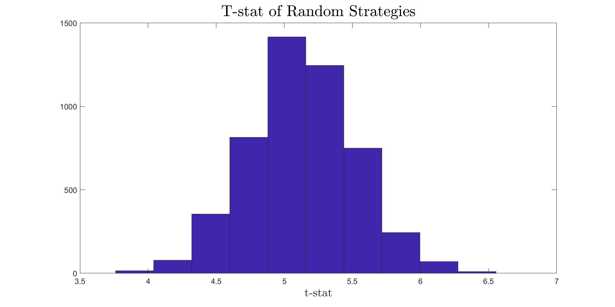the histogram:

There’s no t-stat that is lower than -2. Actually, all of the random strategies generate t-stats greater than 2.